Nama Anggota : 1. Erika Dwi Jayanti (211331006)
- Shalula Arbani Dynastillah (211331027)
- Tsaniya Faridah Maulida (211331031)
Kelas : 1A – TTE

PRAKTIKUM RANGKAIAN LISTRIK 2 (RANGKAIAN TRANSIEN RC)

- Vs = 20 volt R1 = 3Ω
R2 = 1 Ω R3 = 9 Ω C = 10 mF
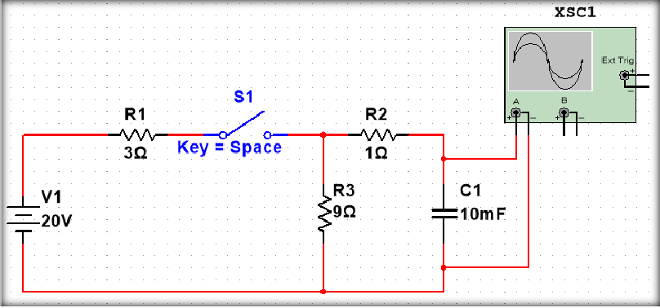
Gambar 1. Gambar Rangkaian Ke-1

𝜏 = R_{Eq}C = (10) (10×10⁻³) = 100 ms
2𝜏 = 2R_{Eq}C = (2) (10) (10×10⁻³) = 200 ms
3τ = 3R_{Eq}C = (3) (10) (10×10⁻³) = 300 ms

  - 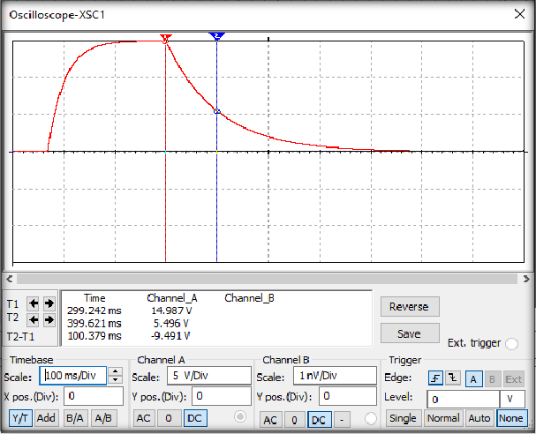Saat 𝒕 = 𝝉

V_{(t)} = 5,496 V V₀ = 14,987 V
t = 𝑉(𝑡) = 5,496
Gambar 2. Display Oscilloscope Saat t = 𝜏

= 0,366717

𝑉0 14,987 𝑉

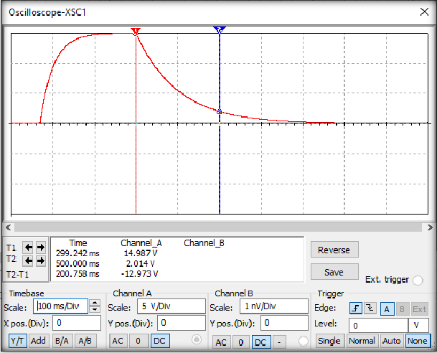b) Saat 𝒕 = 𝟐𝝉

V_{(t)} = 2,014 V V₀ = 14,987 V
t = 𝑉(𝑡) = 2,014
Gambar 3. Display Oscilloscope Saat t = 2τ

= 0,134383

𝑉0 14,987 𝑉

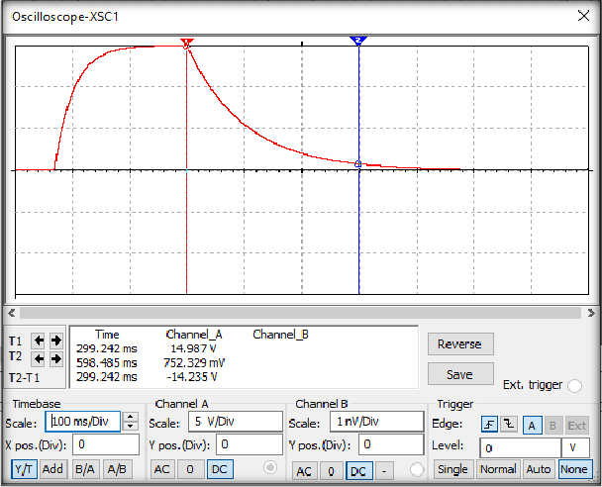c) Saat 𝒕 = 𝟑𝝉
Gambar 4. Display Oscilloscope Saat t = 3τ

V_{(t)} = 0,752329 V V₀ = 14,987 V
t = 𝑉(𝑡) = 0,752329 𝑉 = 0,050198

𝑉0
14,987 𝑉

Vs = 20 volt R1 = 3Ω
R2 = 1 Ω R3 = 9 Ω C = 1 mF
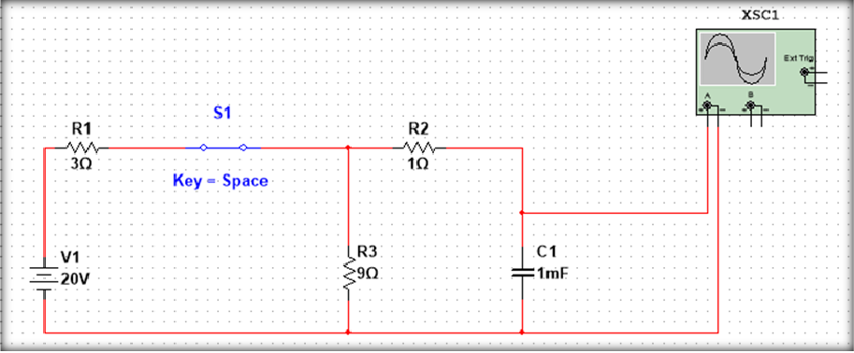
Gambar 5. Gambar Rangkaian Ke-2

𝜏 = R_{Eq}C = (10) (1×10⁻³) = 10 ms
2𝜏 = 2R_{Eq}C = (2) (10) (1×10⁻³) = 20 ms
3τ = 3R_{Eq}C = (3) (10) (1×10⁻³) = 30 ms

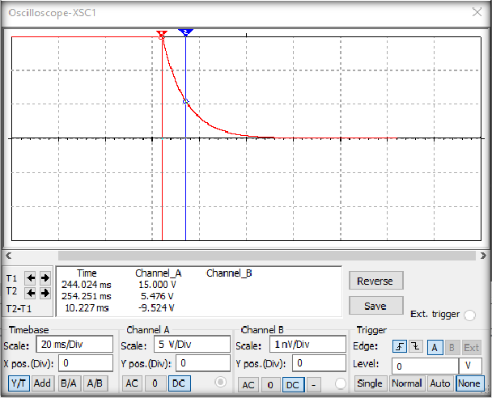d) Saat 𝒕 = 𝝉
Gambar 6. Display Oscilloscope Saat t = 𝜏

V_{(t)} = 5,476 V V₀ = 15 V

t = 𝑉(𝑡) = 5,476 𝑉 = 0,365066

𝑉0
15 𝑉

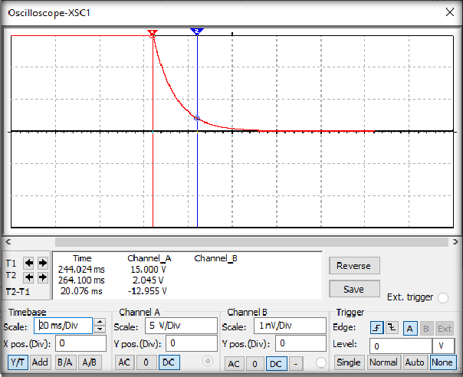e) Saat 𝒕 = 𝟐𝝉

Gambar 7. Display Oscilloscope Saat t = 2τ

V_{(t)} = 2,045 V V₀ = 15 V
t = 𝑉(𝑡) = 2,045 𝑉 = 0,136333

𝑉0
15 𝑉

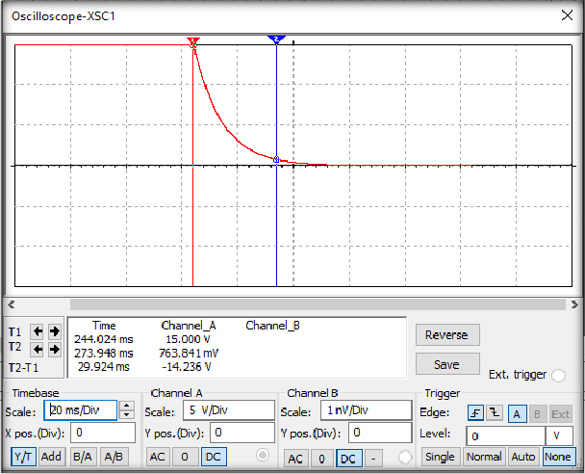f) Saat 𝒕 = 𝟑𝝉

V_{(t)} = 0,763841 V
Gambar 8. Display Oscilloscope Saat t = 3τ

V₀ = 15 V
t = 𝑉(𝑡) = 0,763841 𝑉 = 0,050922

𝑉0
15 𝑉

Vs = 20 volt R1 = 3Ω
R2 = 6 Ω R3 = 9 Ω C = 1 mF
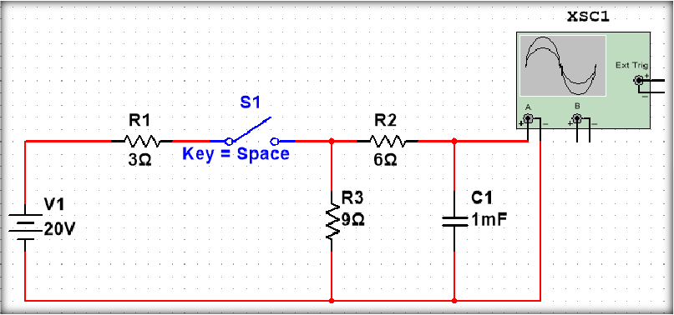
Gambar 9. Gambar Rangkaian Ke-3

𝜏 = R_{Eq}C = (15) (1×10⁻³) = 15 ms
2𝜏 = 2R_{Eq}C = (2) (15) (1×10⁻³) = 30 ms
3τ = 3R_{Eq}C = (3) (15) (1×10⁻³) = 45 ms

  - 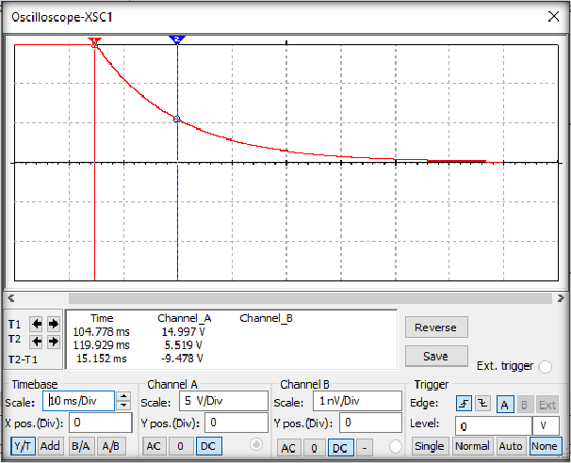Saat 𝒕 = 𝝉
Gambar 10. Gambar Oscilloscope Saat t = 𝜏

V_{(t)} = 5,519 V V₀ = 14,997 V

t = 𝑉(𝑡) = 5,519
= 0,368006

𝑉0 14,997 𝑉

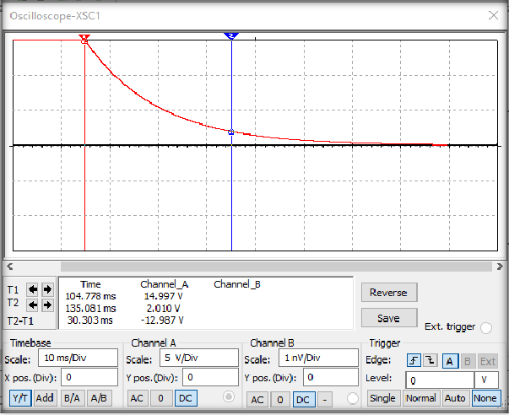b) Saat 𝒕 = 𝟐𝝉

V_{(t)} = 2,010 V V₀ = 14,997 V
t = 𝑉(𝑡) = 2,010
Gambar 21. Display Oscilloscope Saat t = 2𝜏

= 0,134026

𝑉0 14,997 𝑉

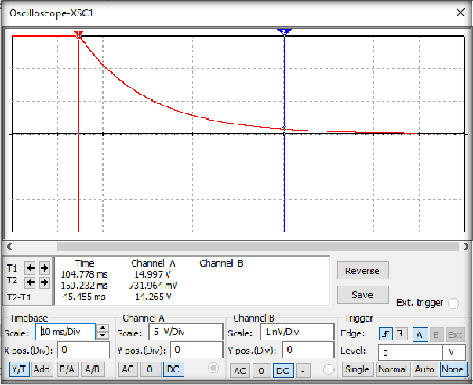c) Saat 𝒕 = 𝟑𝝉

Gambar 3. Display Oscilloscope Saat t = 3𝜏

V_{(t)} = 0,731964 V V₀ = 14,997 V

t = 𝑉(𝑡) = 0,731964 𝑉 = 0,048807

𝑉0
14,997 𝑉

